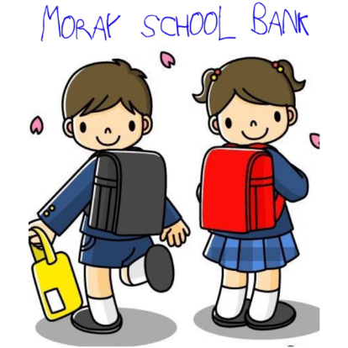
Referral Form

Parent’s Name

Email
Parent’s Tel. No.

Childs Name

Family Address
incl postcode

Childs School Age & DOB

Referrer’s Name

Referrer’s Tel. No.

Reason for Referral
Please explain how
the family/child will
benefit from support
from Moray School
Bank.

Tick to confirm you are aware of the family’s financial income/expenditure

Tick to confirm that you have discussed this referral with the parent and

they have consented to their contact details being passed to Moray
School Bank.

All clothes requirements, sizes etc will be discussed with the family directly
Referrers please only complete page 1

TO BE COMPLETED BY MORAY SCHOOL BANK ONLY

Child name Ref

Child age Sex

Items required size/detail
For Office use only
CH
AD
AW
SB
FSM
CG

Skirt

Pinafore

Trousers

Polo shirt

Shirt

Blouse

Cardigan

Jumper

Socks

Tights

Underpants

Vests

Shoes

Gym shoes

Gym t-shirt

Shorts

Leggings

Jog trousers

School Bag

Pencil case

Lunch box

Water bottle

Jacket

Ref received Referral Actioned

Ref completed Referral Closed

